CHAROTAR UNIVERSITY OF SCIENCE AND TECHNOLOGY
FACULTY OF TECHNOLOGY AND ENGINEERING (FTE)
DEVANG PATEL INSTITUTE OF ADVANCE TECHNOLOGY AND RESEARCH
QUESTION BANK 1: UNIT 2
Define Agile Software Engineering. Who does it and what are steps involved in it?
ANS:
Agile software development refers to software development methodologies centred around the idea of iterative development, where requirements and solutions evolve through collaboration between self-organizing cross-functional teams. The ultimate value in Agile development is that it enables teams to deliver value faster, with greater quality and predictability, and greater aptitude to respond to change
Define the roles in Scrum? Explain Agile software development process in detail. Differentiate between Scrum and Sprint.
ANS:
The distinction between Sprint and Scrum is that they are two linked but different terms. Scrum is a framework often used in Agile methodology, and a Sprint is part of Scrum’s framework structure. Scrum gives meetings, tools, and roles, while a Sprint is a defined period for creating a feature.
With a neat sketch, describe agility and the cost of change.
ANS:
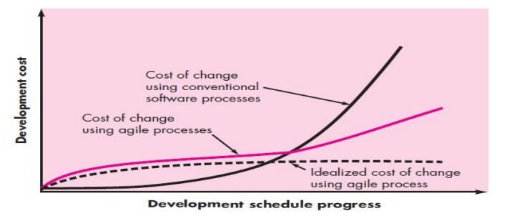
An agile process reduces the agility and cost of change because software is released in increments and change can be better controlled within an increment.
Agility argue that a well-designed agile process “flattens” the cost of change curve shown in following figure, allowing a software team to accommodate changes late in a software project without dramatic cost and time impact.
When incremental delivery is coupled with other agile practices such as continuous unit testing and pair programming, the cost of making a change is attenuated.
Although debate about the degree to which the cost curve flattens is ongoing, there is evidence to suggest that a significant reduction in the cost of change can be achieved.
What are the key assumptions that are addressed for any agile software process?
ANS:
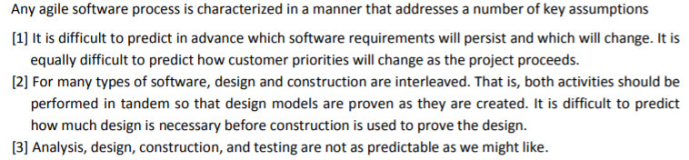
To achieve agility, a set of agility principles needs to be followed. If yes, mention the agility principles. If no, justify the answer.
ANS:
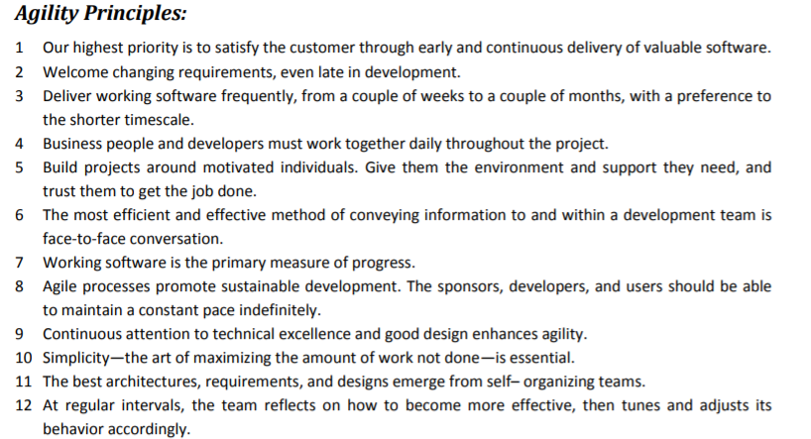

If members of the software team are to drive the characteristics of the process that is applied to build software, mention the key traits that must exist among the people on an agile team and the team itself.
With a neat sketch, explain the extreme programming process.
ANS:
QUALITIES OF AGILE TEAM:
  - Self-Organizing
  - Cross-Functional
  - Collective Ownership
  - Decisiveness
  - Resilience
  - Team-Identity
  - Courageous
  - Collaboration
  - Effective Communication
  - Conflict Management
  - Resource Management
  - Result-Orientation
  - Problem Solving
  - Critical Thinking
  - Adaptability
  - Innovation & Creativity
  - Technical/ Professional Expertise
  - Planning Skills
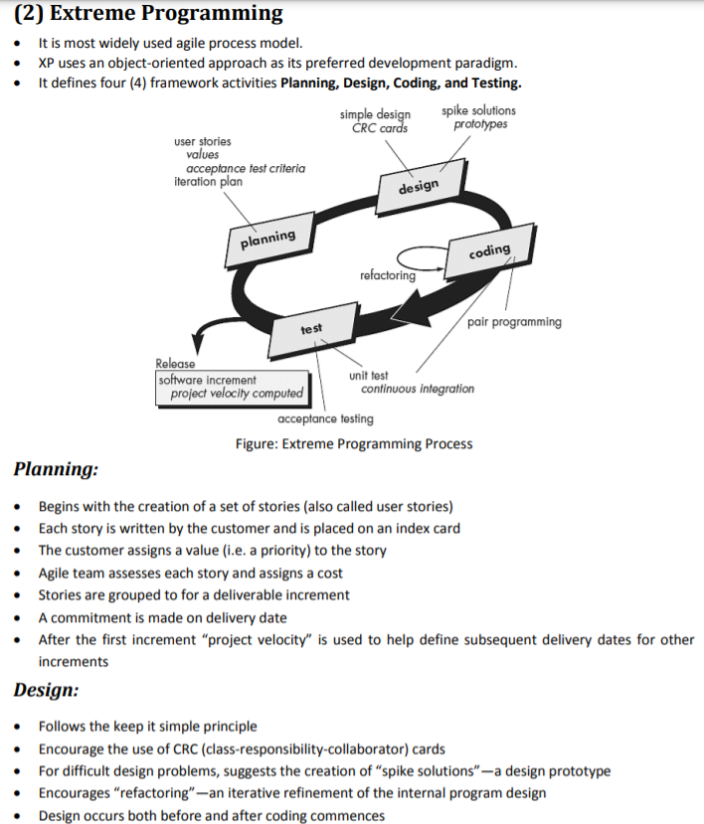
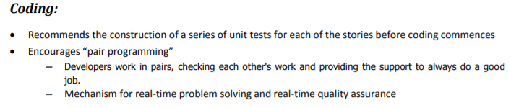
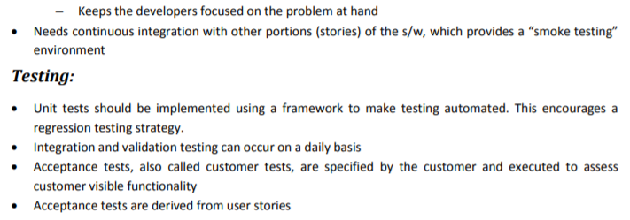
Define the following terms:
  - Pair-programming
  - Refactoring
  - Industrial XP
  - Toolset for agile process
  - Agile Team
  - XP story
ANS:
- Pair-programming: Pair programming is an agile software development technique in which two programmers work together at one workstation. One, the driver, writes code while the other, the observer or navigator, reviews each line of code as it is typed in.
- Refactoring: Refactoring or Code Refactoring is defined as systematic process of improving existing computer code, without adding new functionality or changing external behaviour of the code. It is intended to change the implementation, definition, structure of code without changing functionality of software. It improves extensibility, maintainability, and readability of software without changing what it actually does.
- Industrial XP: Extreme Programming (XP) is a widely used method for software development. This method is used to improve the quality of software. However, the use of XP is limited to small and medium organization. Therefore, Industrial Extreme Programming (IXP) is developed to meet the needs of larger organization as an evolution of XP.
- Toolset for agile process: These are the tools used by agile managers to push task to these tools so that developers can keep track directly from their IDE’s.
Examples: JIRE, AGILE BENCH, PIVOTAL TRACKER, PLANBOX, VERSIONONE, LEANKIT
- Agile Team: An Agile team is a group of employees, contractors, or freelancers responsible for executing an Agile project. Agile teams are typically co-located and often wholly dedicated to the project during its timeline, with no obligations to other projects.
- XP story: A typical XP user story is a short description (usually in two or three sentences) of a certain function of the future product. These stories do not provide enough information to turn them into project tasks. In Extreme Programming they are used to create release plans.

Enlist the other Agile Process models and explain any two in detail.
ANS:
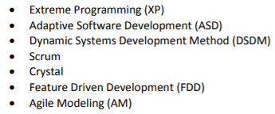
1: ASD:
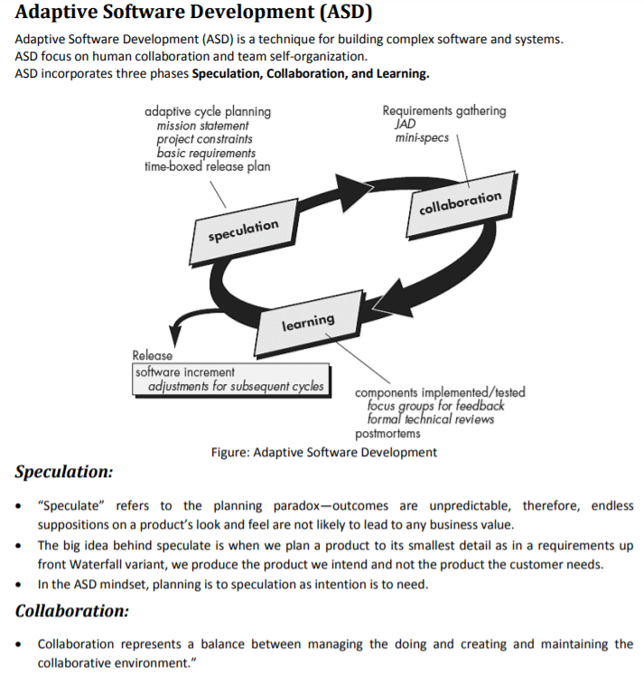
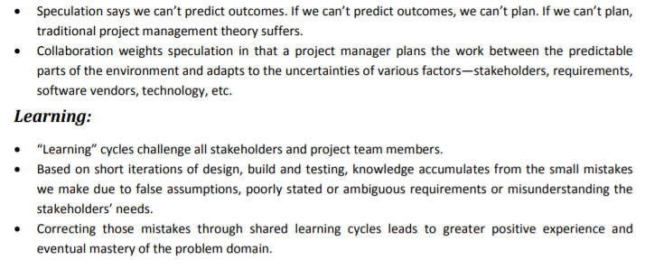

- DSDM
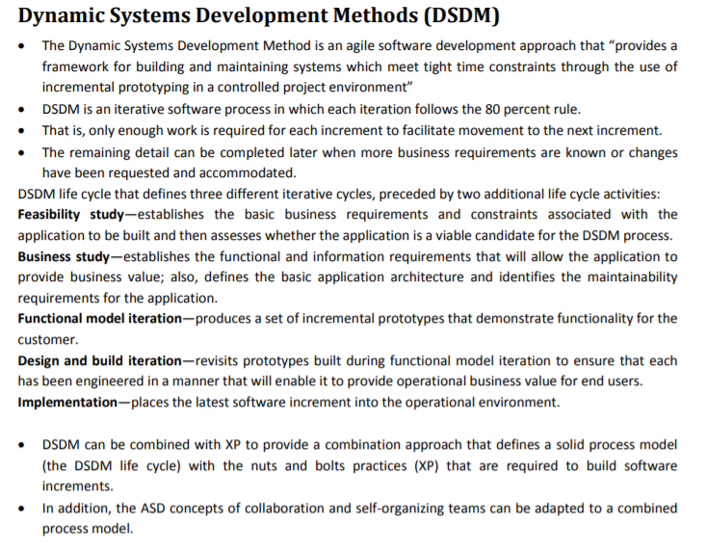
- SCRUM & CRYSTAL
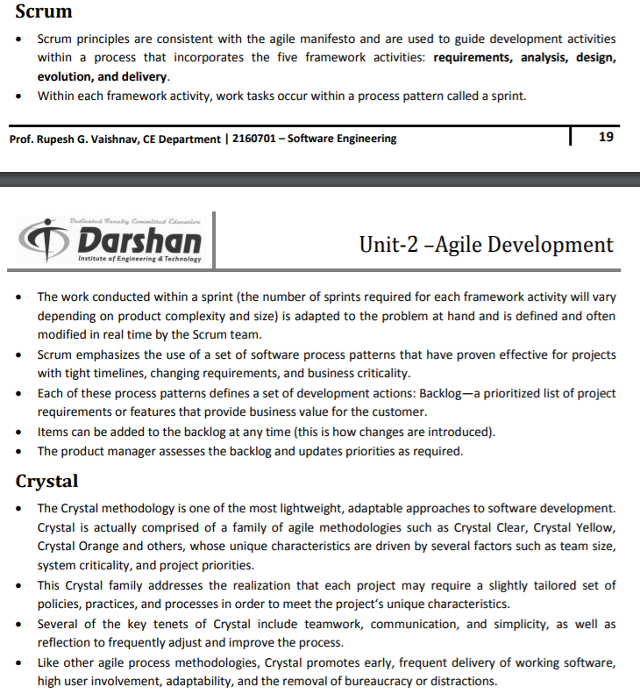
4.FEATURE DRIVEN DEVELOPMENT & AGILE MODEL
